Exercise 15: Restful API with Node app and MongoDB, Mongoose

Objective
In this exercise, you’ll learn to create a RESTful API involves building an application that uses HTTP requests to GET, PUT, POST, and DELETE data. Using Node.js, MongoDB, and Mongoose for this task is a popular choice due to their efficiency and scalability..

Exercise
- Using node-mongoose app
- Add code in articleRouter.js (routes folder) as below
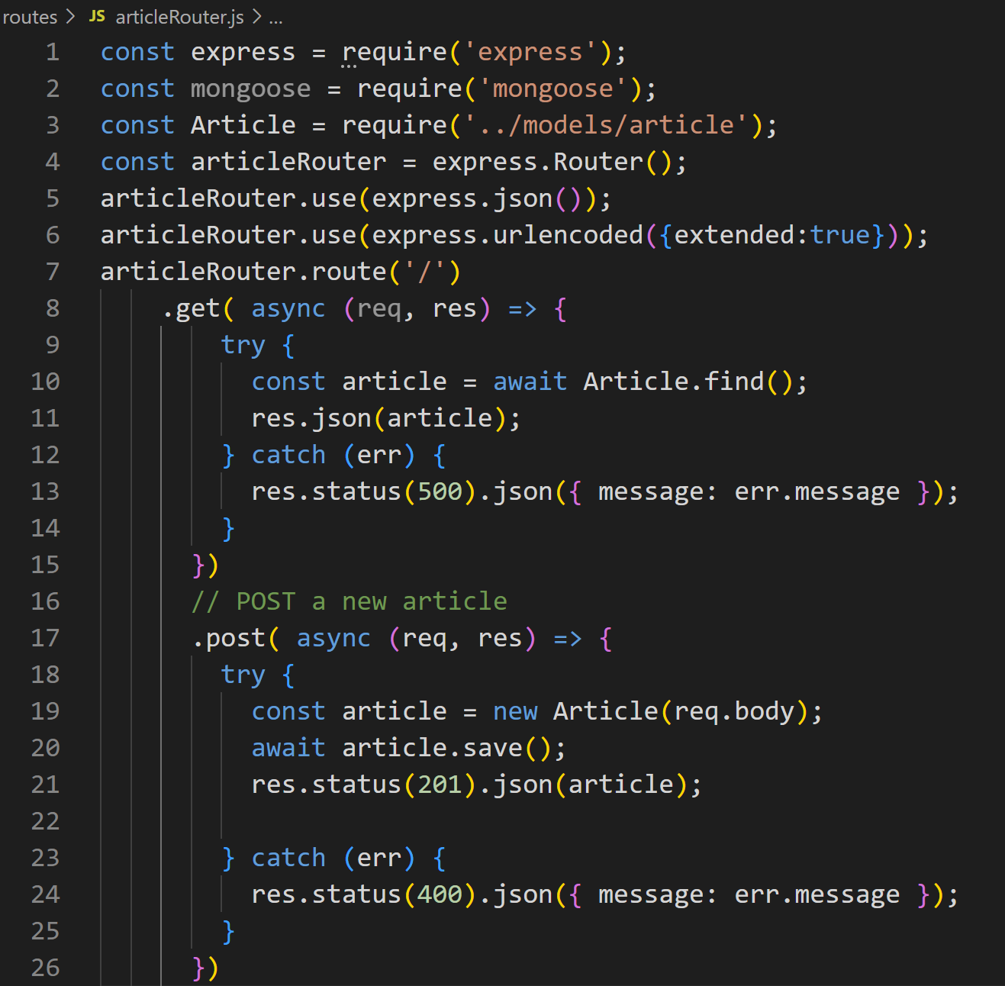

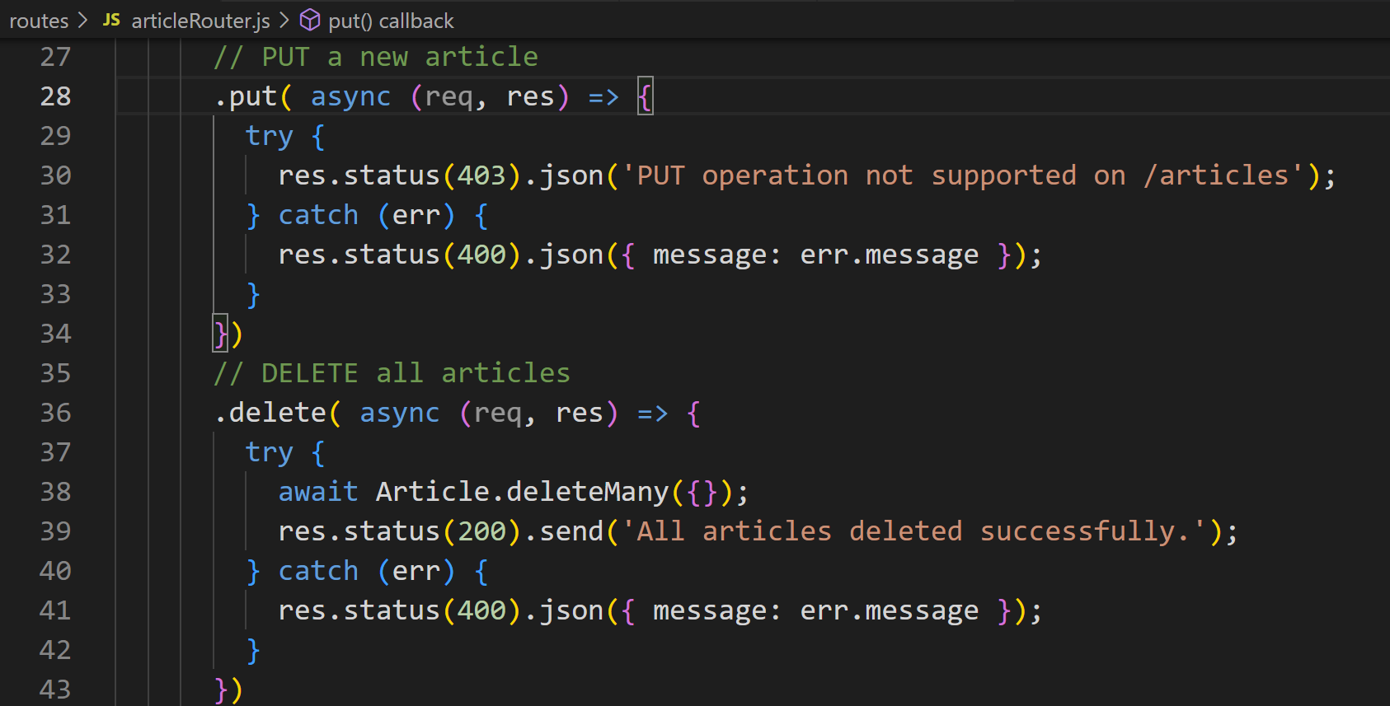

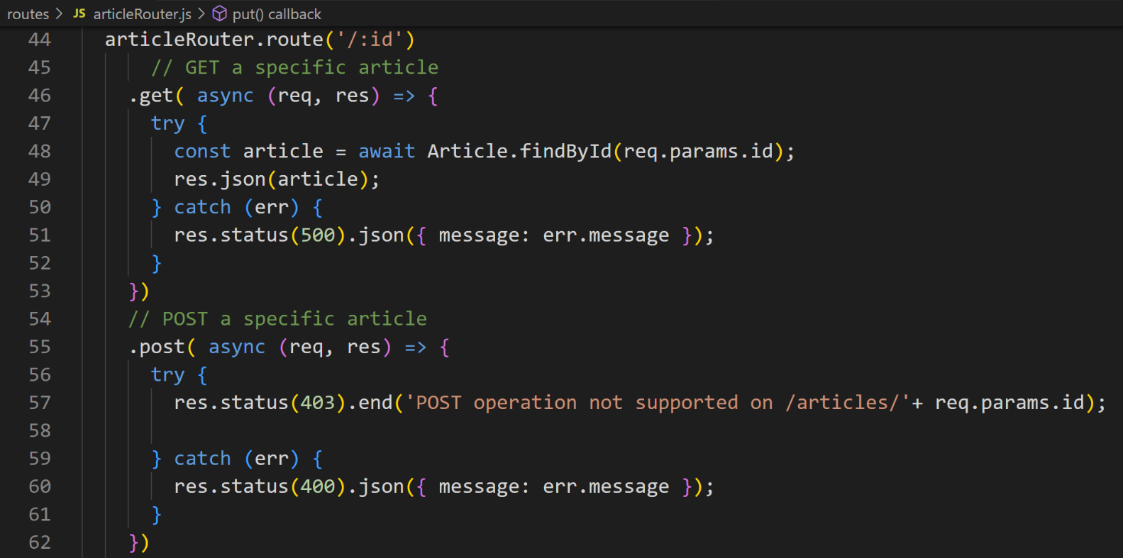

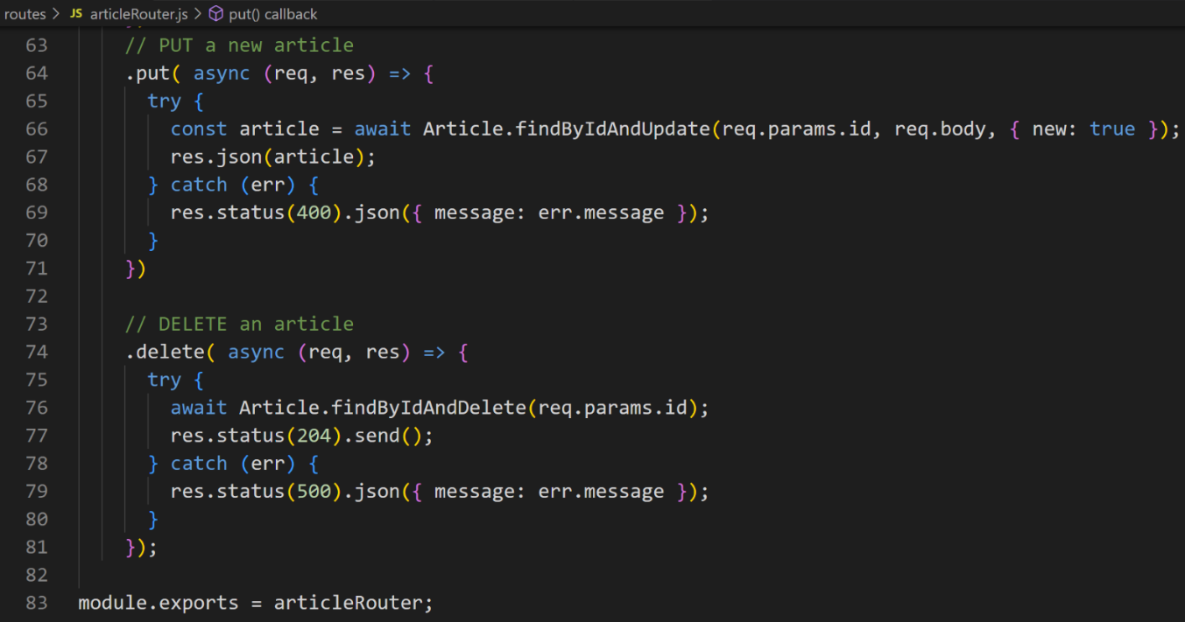
- Test with Postman
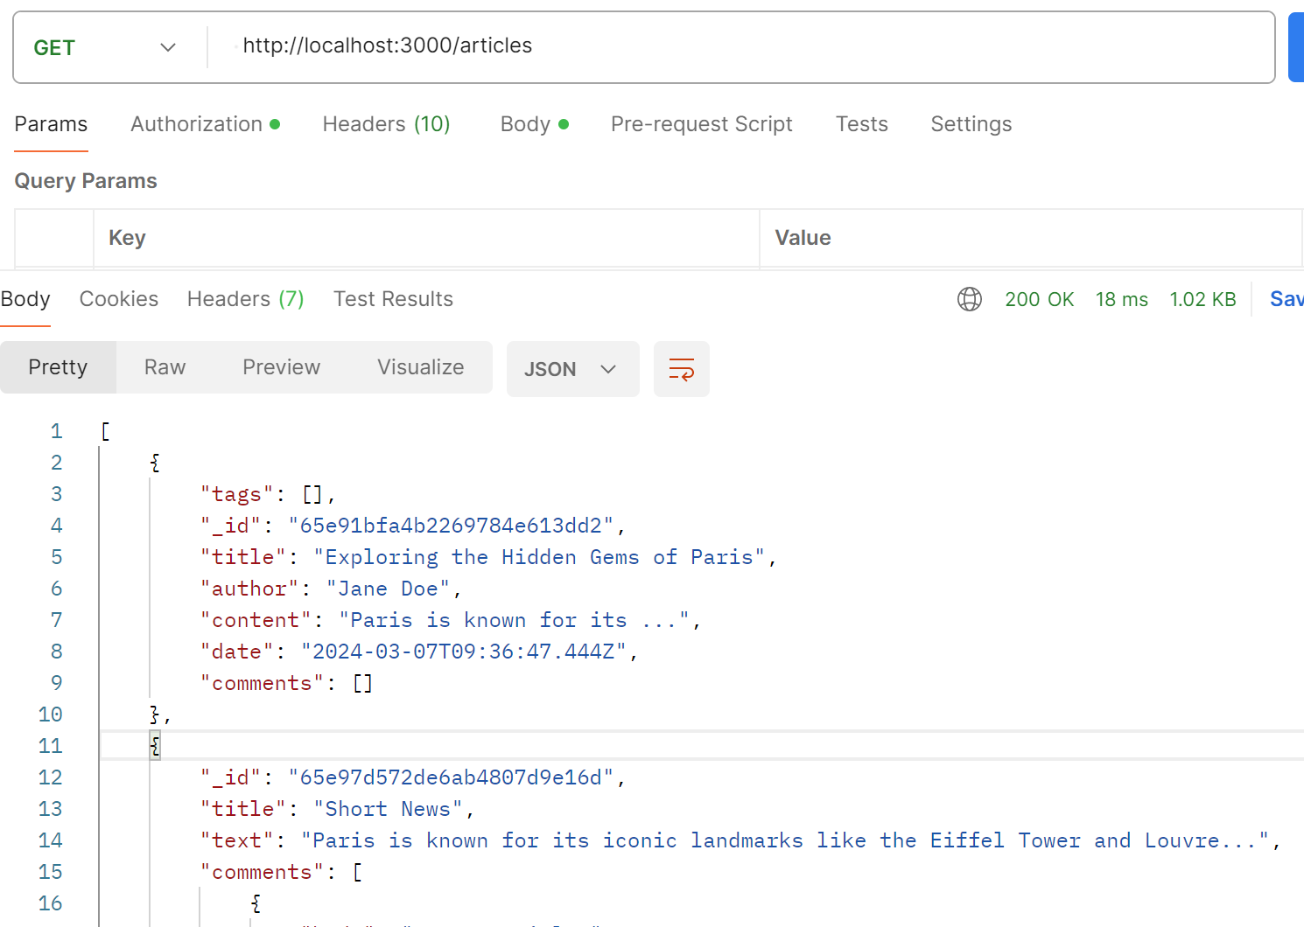
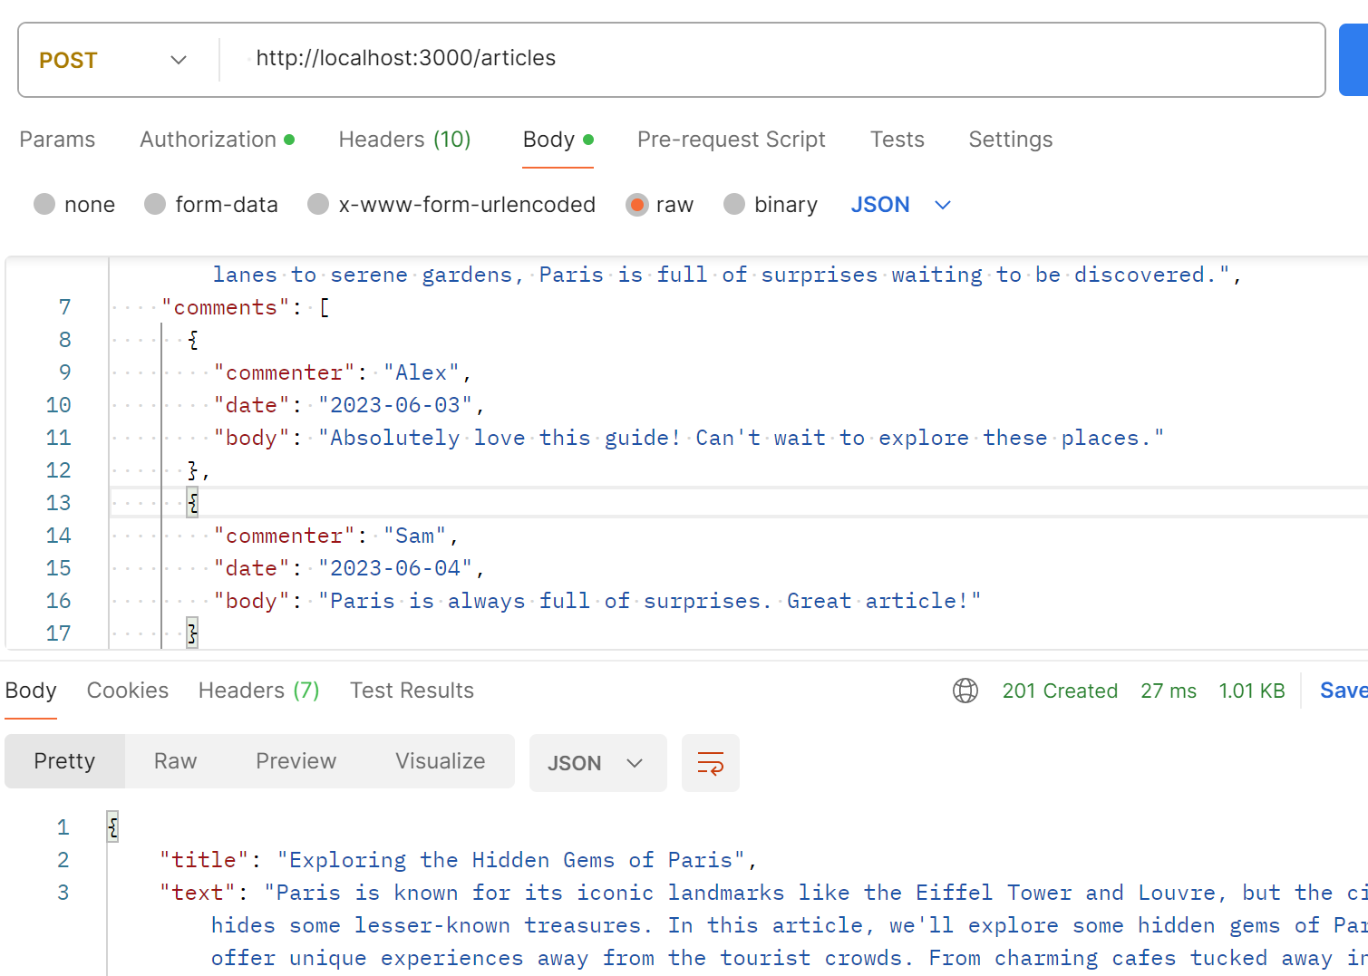
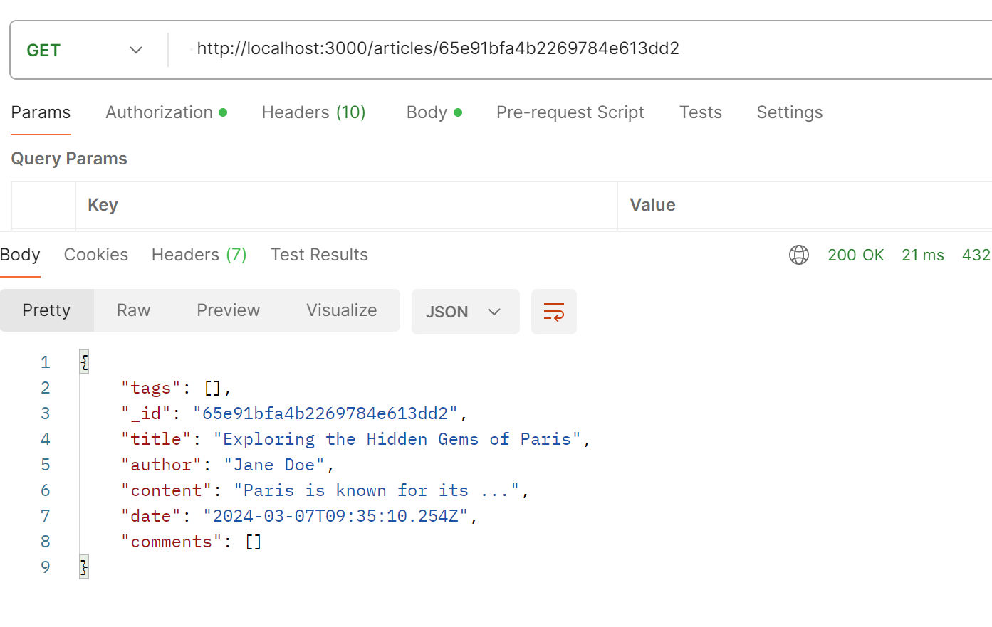
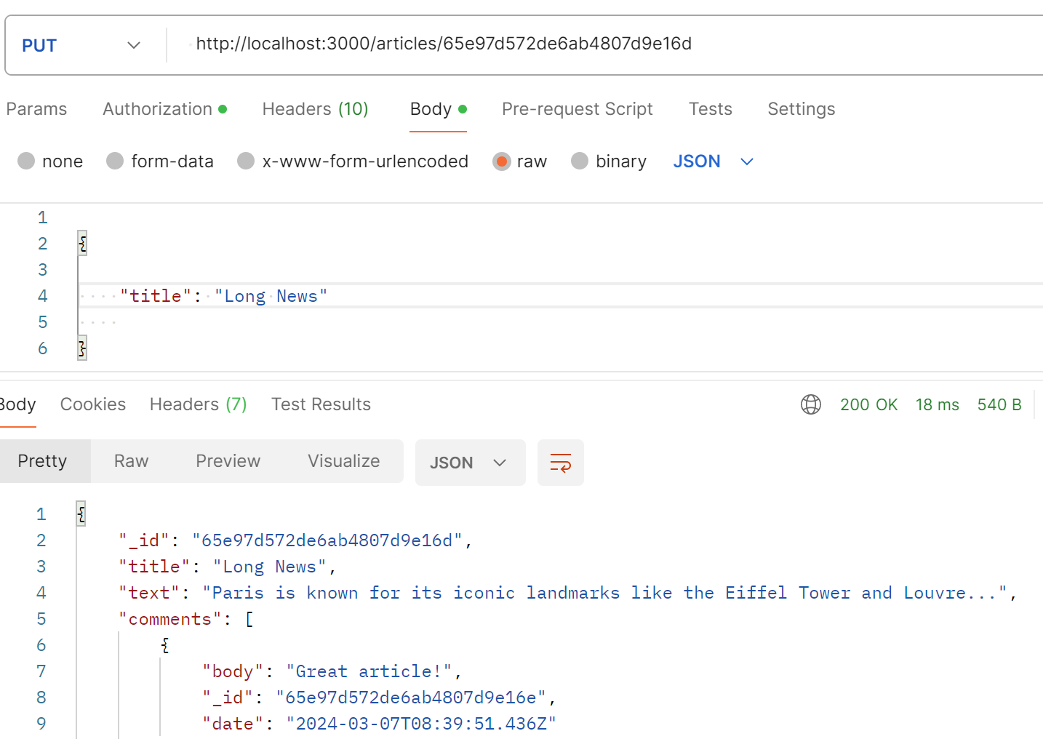

Conclusion
This guide covers the basics of setting up a RESTful API with Node.js, MongoDB, and Mongoose. There are many more aspects to consider, such as adding authentication, handling errors more gracefully, and structuring your project using MVC patterns for larger applications. As you become more comfortable with these technologies, you can start exploring these advanced exercises to improve your application.

